/*

* Justin Mendes

* December 25, 2016

* Unit 5 Activity 1 Program/Question 1

* This program will ask the user to enter the high temperature for each day of one week, store the temperatures in an array, and output all temperatures that have been stored into the array.

*/

**import** java.io.BufferedReader;

**import** java.io.IOException;

**import** java.io.InputStreamReader;

**public** **class** TemperatureStats

{

**public** **static** **void** main(String[] args) **throws** NumberFormatException, IOException

{

//Variable Declarations and Initializations

**int** weather[] = **new** **int** [7], restart = 1, avgTemp = 0;

String day[] = {"Sunday", "Monday", "Tuesday", "Wednesday", "Thursday", "Friday", "Saturday"};

BufferedReader br = **new** BufferedReader (**new** InputStreamReader(System.***in***));

**while** (restart == 1)

{

System.***out***.println("Daily Temperatures for the week\n==============================");

System.***out***.println("This program records the daily maxium temperature for a week.\n");

**for** (**int** i = 0; i < 7; i++)

{

System.***out***.println("Enter the temperature for " + day[i] + " (°C):");

weather[i] = Integer.*parseInt*(br.readLine());

}//end loop

System.***out***.println("Temperatures\n===============");

**for**(**int** i = 0; i < 7; i++)

{

System.***out***.println(day[i] + ": " + weather[i] + " °C");

}//end loop

avgTemp = *averageValue*(weather);

System.***out***.println("\nAvg. Temp: " + avgTemp + " °C");

System.***out***.println("\nEnter 1 to input new temperatures:");

restart = Integer.*parseInt*(br.readLine());

}//end loop

}//end main

**public** **static** **int** averageValue(**int** weather[])

{

**int** total = 0;

**for** (**int** i = 0; i < weather.length; i++)

{

total += weather[i];

}//end loop

**return** total / weather.length;

}//end method averageValue

}//end class

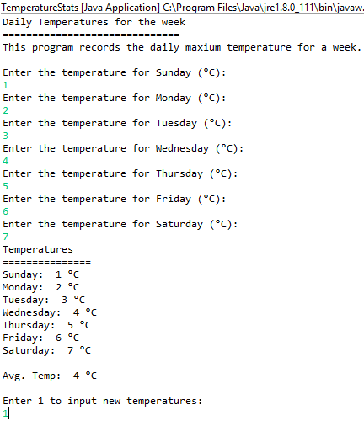

/*

* Justin Mendes

* December 26, 2016

* Unit 5 Activity 2 Program/Question 2

* This program will output the percentage of people 15 and over that attend religious services weekly

*/

**import** java.io.BufferedReader;

**import** java.io.IOException;

**import** java.io.InputStreamReader;

**import** java.text.DecimalFormat;

**public** **class** Declining

{

**public** **static** **void** main(String[] args) **throws** NumberFormatException, IOException

{

//Variable Declarations and Initializations

**int** year = 0, restart = 1;

**double** percentage[] = **new** **double**[39];

DecimalFormat oneDigit = **new** DecimalFormat ("#,##0.0");

BufferedReader br = **new** BufferedReader (**new** InputStreamReader(System.***in***));

**while** (restart == 1)

{

percentage[0] = 30;

System.***out***.println("Declining Attendance\n==================");

System.***out***.println("Attendance for weekly religious services has been steadily declining\nfrom 1985. This program displays the percentage of Canadians over\nthe age of 15 that attend from any year from 1985-2025.");

System.***out***.println("\nEnter a year from 1985 to 2025:");

year = Integer.*parseInt*(br.readLine());

**while** (year < 1985 || year > 2025)

{

System.***out***.println("Invalid year input...\nEnter another year that is from 1985 - 2025:");

year = Integer.*parseInt*(br.readLine());

}//end loop

**for** (**int** i = 0; i <= (year - 1985); i++)

{

percentage[i + 1] = percentage[i] - 0.45;

}//end loop

System.***out***.println("\nPercentage of Weekly Attendance: " + oneDigit.format(percentage[year - 1985]) + "%\n");

System.***out***.println("Enter 1 to input another year:");

restart = Integer.*parseInt*(br.readLine());

}//end loop

}//end main

}//end class

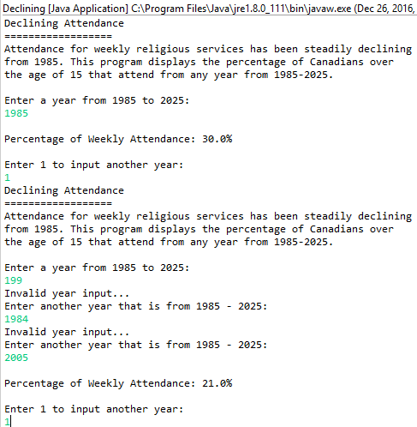

/*

* Justin Mendes

* December 26, 2016

* Unit 5 Activity 2 Program/Question 3

* This program will generate a specified number of random integers between any two values specified by the user.

*/

**import** java.io.BufferedReader;

**import** java.io.IOException;

**import** java.io.InputStreamReader;

**import** java.text.DecimalFormat;

**public** **class** RandomNumbers

{

**static** **int** *highVal* = 1, *lowVal* = 0, *amountOfNumbers*, *randomNumber*;

**public** **static** **void** main(String[] args) **throws** NumberFormatException, IOException

{

//Variable Declarations and Initializations

**int** generated[] = **new** **int**[0], restart = 1;

BufferedReader br = **new** BufferedReader (**new** InputStreamReader(System.***in***));

DecimalFormat twoDigit = **new** DecimalFormat ("#,##0.##");

**while** (restart == 1)

{

System.***out***.println("Random Number Generator\n========================");

System.***out***.println("\nEnter the number of random number to generate:");

*amountOfNumbers* = Integer.*parseInt*(br.readLine());

//checks if the ranges are valid

*rangeProcess*(br);

System.***out***.println("\nGENERATED NUMBERS\n==============");

generated = **new** **int**[*amountOfNumbers*];

**for** (**int** i = 0; i < *amountOfNumbers*; i++)

{

*randomWholeNumber*();

generated[i] = *randomNumber*;

System.***out***.println(generated[i]);

}//end loop

System.***out***.println("\nAverage of random numbers: " + twoDigit.format(*averageValue*(generated)));

*averageValue*(generated);

System.***out***.println("\nEnter 1 to try again:");

restart = Integer.*parseInt*(br.readLine());

}//end loop

}//end main

**public** **static** **int** randomWholeNumber()

{

//to make randomNumber meet the conditions of the while loop, and refresh

*randomNumber* = *highVal* + 1;

**while** (*randomNumber* > *highVal* || *randomNumber* < *lowVal*)

{

*randomNumber* = (**int**) Math.*round*(((Math.*random*() * *highVal*) + *lowVal*));

}//end loop

**return** (*randomNumber*);

}//end method randomWholeNumber

**public** **static** **void** rangeProcess(BufferedReader br) **throws** NumberFormatException, IOException

{

**do**

{

**if**(*lowVal* > *highVal*)

{

System.***out***.println("INVALID RANGE: Lower range cannot be bigger than upper range.");

}//end if

System.***out***.println("\nEnter the upper range:");

*highVal* = Integer.*parseInt*(br.readLine());

System.***out***.println("\nEnter the lower range:");

*lowVal* = Integer.*parseInt*(br.readLine());

}//end loop

**while** (*lowVal* > *highVal*);

}//end method rangeProcess

**public** **static** **double** averageValue(**int** generated[])

{

**double** total = 0;

**for** (**int** i = 0; i < generated.length; i++)

{

total += generated[i];

}//end loop

**return** total / generated.length;

}//end method averageValue

}//end class

